Software Engineering Project - Phase III
Software Design and Modeling
Project: Local Classified Ads Platform / Bizpartner.al

1. Software Architecture

1.1 System Architecture
The Local Classified Ads Platform is a web-based system that allows visitors and registered users to browse, post, and manage classified advertisements for local opportunities such as products, jobs, services, and real estate. The system is divided into three main layers: frontend, backend, and database.
Main system flow:
- Guest visitor or registered user opens the web application through the frontend.
- The frontend displays pages such as Home, Login/Register, Ad Listings, Ad Details, and Post Ad form.
- When the user performs an action, the frontend sends a request to the backend.
- The backend validates the request and sends database operations through the data access component.
- The database stores and retrieves users, ads, categories, messages, reports, and notifications.
- The backend sends the result back to the frontend, and the frontend displays confirmation, search results, or error messages.

1.2 Component Diagram (UML)
The component diagram shows the main parts of the system and how they communicate. The left side contains the external actors. The middle part contains the frontend and backend components. The right side contains the data access component and database.
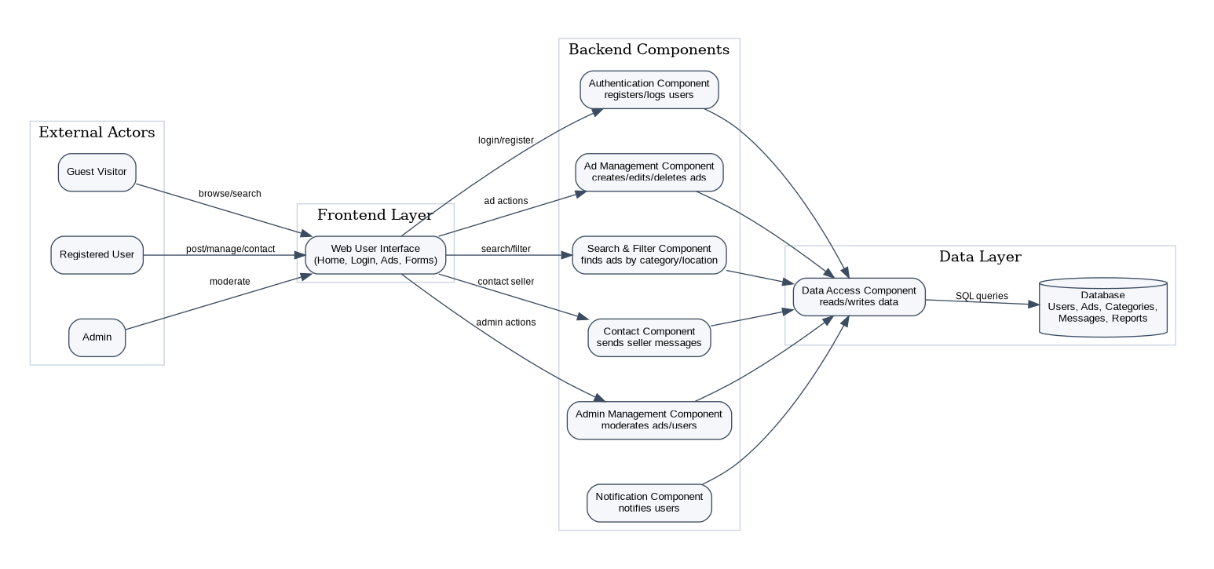
Figure 1. UML Component Diagram - Local Classified Ads Platform
Component explanations:
- Guest Visitor: browses ads, searches listings, and views ad details without logging in.
- Registered User: can register, log in, post ads, edit ads, save ads, and contact sellers.
- Admin: manages users, moderates reports, and removes inappropriate content.
- Web User Interface: contains the visible pages and forms used by visitors, users, and admins.
- Authentication Component: handles registration, login, logout, and user identity verification.
- Ad Management Component: creates, edits, deletes, and publishes classified ads.
- Search & Filter Component: searches ads using keywords, category, location, price, or date.
- Contact Component: allows users to contact sellers through stored messages or contact requests.
- Admin Management Component: supports moderation of ads, reports, and user accounts.
- Notification Component: creates notifications when important events happen, such as messages or moderation updates.
- Data Access Component: reads and writes data from the database.
- Database: stores all persistent data, including users, ads, categories, messages, reports, and notifications.

2. Detailed Design

2.1 Class Diagram
The class diagram describes the main classes of the platform, their attributes, methods, and relationships. The main classes are User, Admin, Ad, Category, Message, Report, Notification, SearchService, and Database.
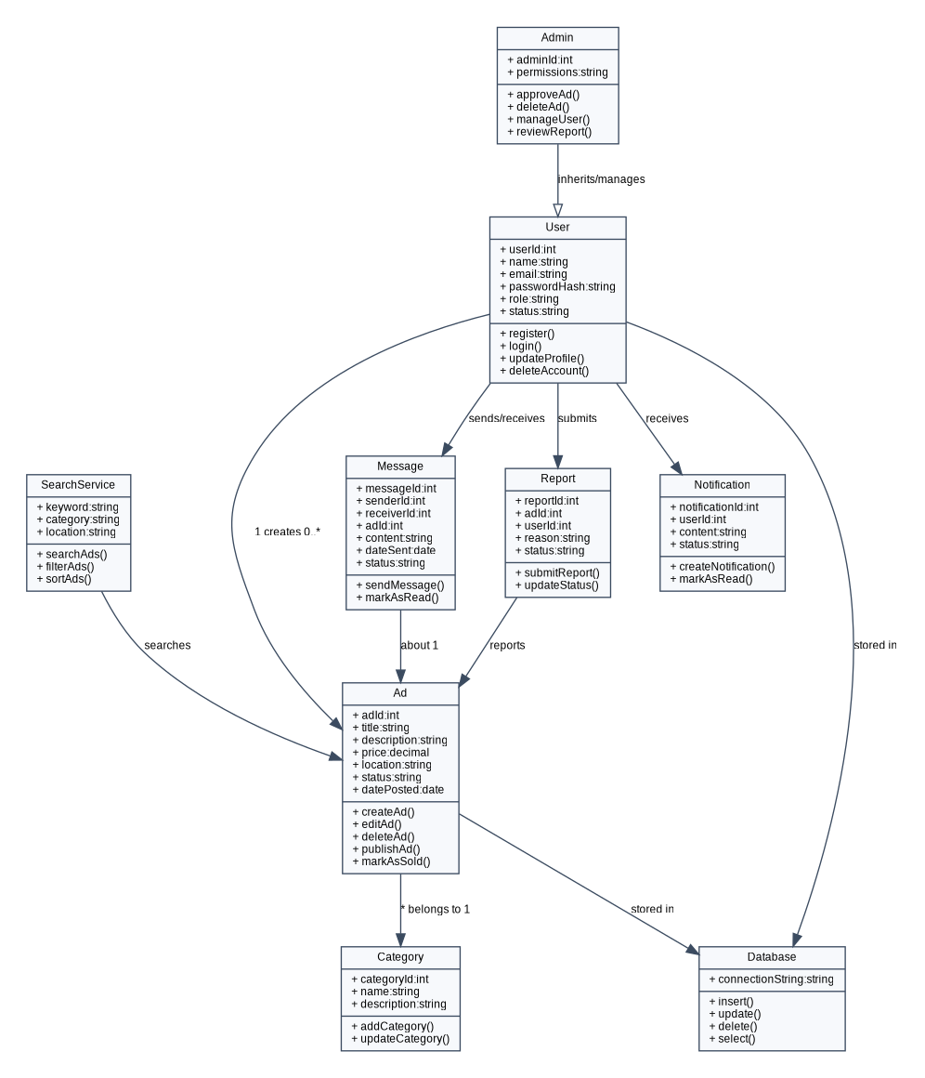
Figure 2. Class Diagram - Main System Classes

2.2 Sequence Diagrams
The following sequence diagrams show step-by-step interactions for three key processes in the platform.
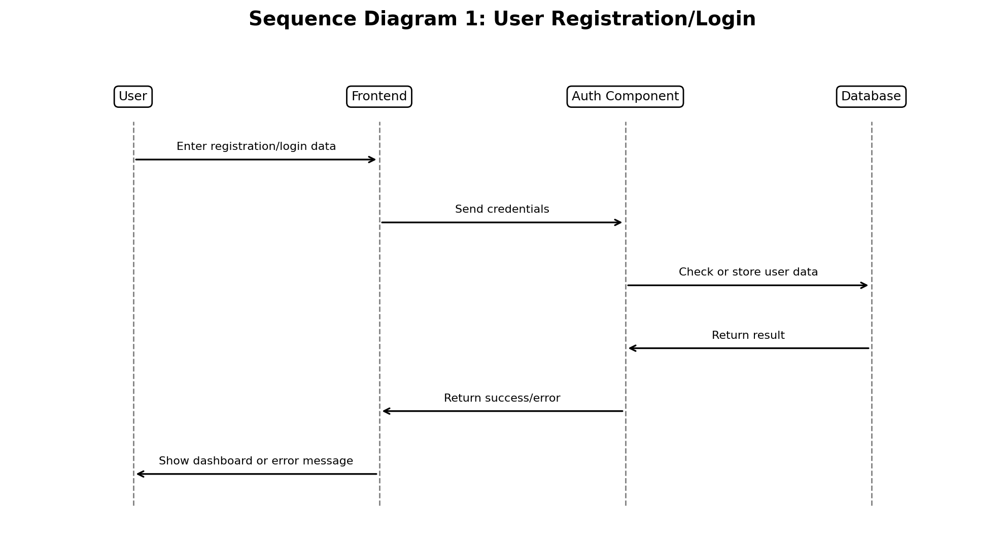
Figure 3. Sequence Diagram - User Registration/Login
This process starts when a user enters registration or login data. The frontend sends the credentials to the authentication component, which checks or stores the user data in the database and returns a success or error response.
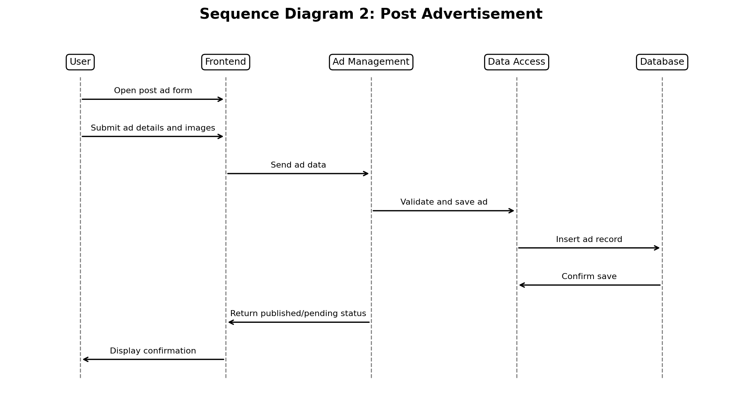
Figure 4. Sequence Diagram - Posting an Advertisement
This process starts when a registered user submits an ad. The frontend sends the ad details to the ad management component, which validates the data and stores the advertisement in the database.

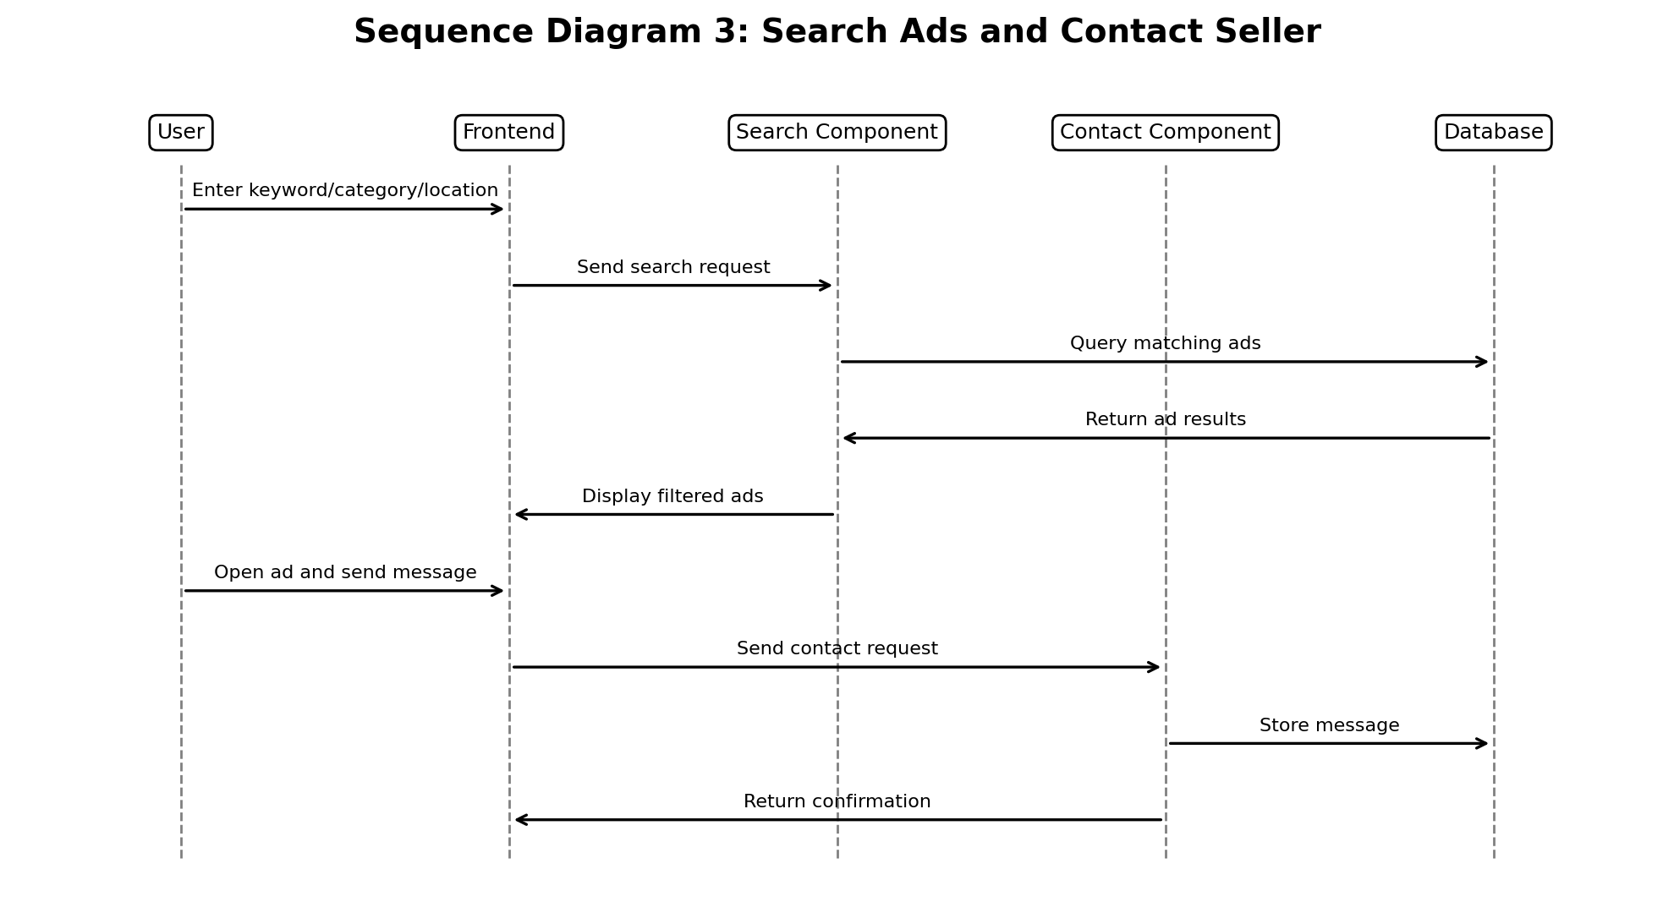
Figure 5. Sequence Diagram - Search Ads and Contact Seller
This process shows how a user searches for ads and contacts a seller. Search criteria are sent to the search component, results are retrieved from the database, and the contact message is stored through the contact component.

3. Modeling

3.1 Use Case Diagram
The use case diagram shows how the main actors interact with the system. The actors are Guest Visitor, Registered User, and Admin.
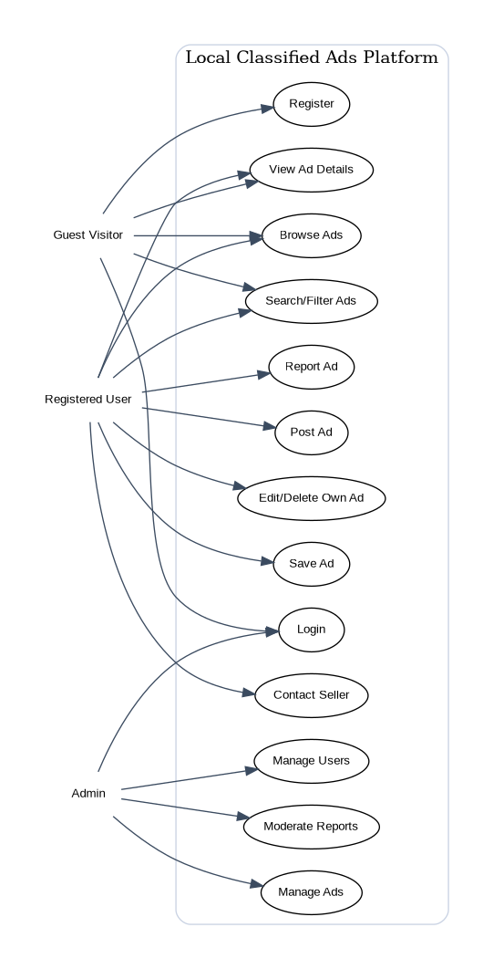
Figure 6. Use Case Diagram - System Actors and Functions

3.2 Activity Diagrams
Activity diagrams describe the workflow of important system tasks. The diagrams below show the process of posting an ad and reporting/moderating inappropriate content.
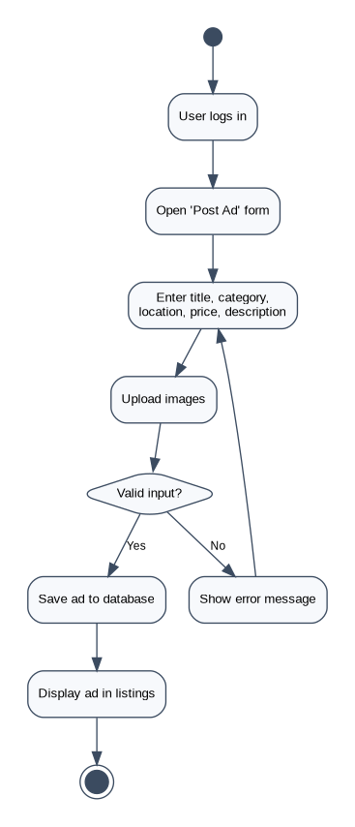
Figure 7. Activity Diagram - Post Advertisement

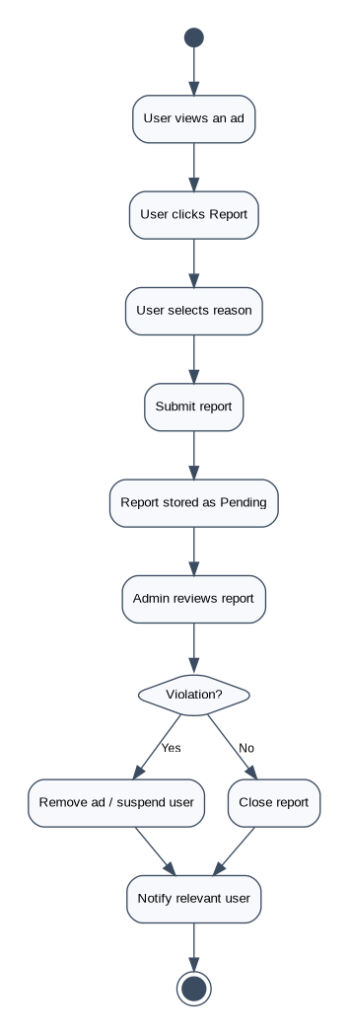
Figure 8. Activity Diagram - Report and Moderate Advertisement

3.3 State Diagrams
State diagrams show the possible states of important objects and how they change based on user or admin actions.
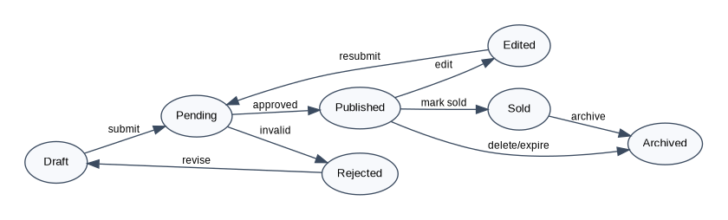
Figure 9. State Diagram - Advertisement States
An advertisement may start as a draft, become pending after submission, be published after approval, and later be edited, sold, archived, or rejected.
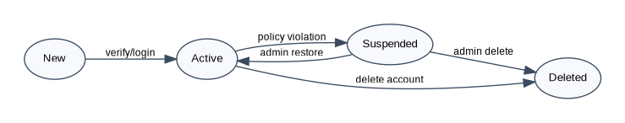
Figure 10. State Diagram - User Account States
A user account may become active after registration/login. It can be suspended after violations or deleted by the user or admin.
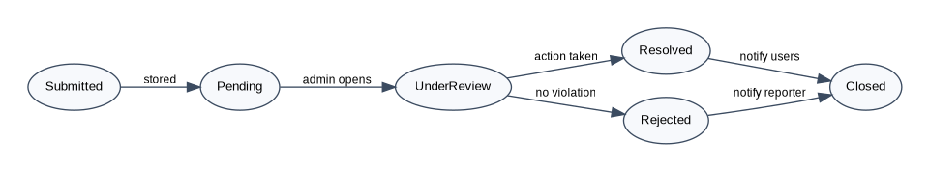
Figure 11. State Diagram - Report States
A report is submitted by a user, reviewed by an admin, and then resolved, rejected, or closed depending on the decision.

Conclusion
This phase defines the software design and modeling of the Local Classified Ads Platform. The system architecture, component diagram, class diagram, sequence diagrams, use case diagram, activity diagrams, and state diagrams provide a clear technical view of how the application will be structured and how the main processes will work.

